William Christoffer Rudolph-Lund
NMBU
Nocturnal far-red treatment led to reduced tip burn in CRISPI lettuce
Abstract:

Towards the year 2050 it is estimated that the global population will number close to 9,1 billion people and that net food production will have to increase by 70 % in the period from 2007 to 2050. The three fold challenge of producing environmental and social sustainable food, meet the global food demands and feed the world’s poorest people require changes to the way our food is produced, stored, processed and distributed. Going forwards it is therefore an emphasis on good agricultural practices and innovative solutions that can help solve upcoming food challenges. One such potential solution is hydroponically-grown fruits and vegetables as they may help to feed the world regardless of available space, soil quality or climate. While fast crop production systems can optimize the amount of produce produced per unit time, a physiological disorder known as tip burn is more prone to occur when the rapidly growing lettuce tips are calcium deficient. The high incidence of tip burn can largely be attributed to the increased growth rate and lack of transpiration
Transpiration is the key process of water movement through a plant, it is not only responsible for nutrient transportation but also in cooling down the plant. We found that the FR-light treatment significantly reduced outer tip burn in lettuce as well as removing inner tip burn altogether. We speculate that the effects arise from a more open morphology, higher transpiration and nutrient uptake. FR-diodes potentially offer growers an easy and cheap installment in existing growing systems that want to reduce the severity of tip burn.

Key words: Hydroponics, tip burn, Crispi lettuce, FR-light

Introduction:

Towards the year 2050 it is estimated that the global population will number close to 9,1 billion people and that net food production will have to increase by 70 % in the period from 2007 to 2050 (FAO, 2009). Securing the worlds future food security depends upon increasing food production substantially while shrinking the agriculture´s environmental footprint dramatically(Ramankutty et al., 2011). The three fold challenge of producing environmental and social sustainable food, meet the global food demands and feed the world’s poorest people require changes to the way our food is produced, stored, processed and distributed (Beddington et al., 2010). Substantially more food could be produced and purchased if methods were found to close the yield gaps of agricultural production (Beddington et al., 2010). Going forwards it is therefore an emphasis on good agricultural practices and innovative solutions that can help solve upcoming food challenges.

One such potential solution is hydroponically-grown fruits and vegetables as they may help to feed the world regardless of available space, soil quality or climate(Drew & Stanley, 2013). Drew and Stanley (2013) found that hydroponically-grown produce had significantly higher levels of vitamin C and E than their soil grown counter parts. Another study found that hydroponics increased the yield of lettuce 11 times more than conventional produced lettuce although requiring 82 times the amount of energy (Barbosa et al., 2015). While fast crop production systems can optimize the amount of produce produced per unit time, a physiological disorder known as tip burn is more prone to occur when the rapidly growing lettuce tips are calcium deficient(Both, 2002). Tip burn is a concern for growers because it can severely limit their ability to sell their produce and may cause serious economic losses (Mattson, 2015; Saure, 1998). In Norway, one of the major leafy vegetables is Crispi (frillice) lettuce, which made up 18,1 % of the 2015/16 market totaling a revenue of 242 million kroner (OFG, 2016). It is estimated that there is an annual wastage of 15-20% Crispi lettuce as a result of tip burn, accounting for a loss of income close to 20 million kroner (Grofondet, 2017). With the Crispi lettuce market continuing to increase with an additional 50 million kroner the following year, there is increased interest in working on counter preventative tip burn measures (Grofondet, 2017; OFG, 2018).

In literature the term tip burn is often used synonymously to describe what is actually two different abiotic disorder in lettuce (Mattson, 2015).The high incidence of tip burn can largely be attributed to the increased growth rate and lack of transpiration (Both, 2002). When the inner leaves grow quite fast, the compact formation results in a lack of transpiration that causes necrosis in the leaf edges, the physiological disorder known as inner tip burn (Mattson, 2015). While the conditions for inner tip burn are better understood, the reason for outer tip burn is less clear cut as there may be multiple interrelated causes linked to hydric deficit, salt accumulation, high air flow and low air humidity(Mattson, 2015; Périard, Caron, Lafond, & Jutras, 2015). As both outer and inner tip burn can severely limit lettuce growers ability to sell their produce, it is imperative to distinguish between the two abiotic disorder because they each have different causes and preventative measures (Mattson, 2015). One approach which has been used successfully is the use a paddle fan which increases the vertical air movement, and transpiration which results in more nutrients like calcium being transported, thereby preventing tip burn (Brechner, 2013).

Transpiration is the key process of water movement through a plant, it is not only responsible for nutrient transportation but also in cooling down the plant. The rate of transpiration is attributed to the stomata and the movement of guard cells. There are two photoreceptors chlorophyll and blue light receptors that affect the osmotic potential of the guard cells, which again leads to an influx of water (Sveshnikova et al., 2003). An investigation into the mechanisms of the photoreceptors could therefore be an important avenue of investigation for a potential cost effective way of preventing tip burn. Zhen and van Iersel (2017) found that for lettuce plants adding far-red light to shorter wavelengths led to the PSII reaction absorbing photons more efficiently. Furthermore, the increase in quantum yield of photosystem II resulted in a net increase in photosynthesis (Zhen & van Iersel, 2017). Sveshnikova et al. (2003) found that irradiance of far-red light larger than 0,3Wm⁻²s⁻¹ resulted in both a decrease and increase in transpiration rate depending on which leaf was measured. However, more research into the effects of FR- light on transpiration and as a potential mechanism for preventing tip burn is needed.

In terms of commercial production and feasibility for growers, far-red LEDs has the potential to offer a cheap and efficient way to decrease tip burn as most growers in Norway still utilize the traditional HPS lamps and are daunted by the high investment needed to replace HPS lamps with LEDs. HPS lamps have a rather low energy to light conversion, as most of the energy is used to produce heat as well has having a red: far-red ratio close to 6. While LEDs have a better conversion and produce less heat, but can also be customized to get the right PAR specter. As mentioned earlier, the quick installation of a few far-red LEDs alongside the HPS lamps is a much more cost efficient solution should it turn out to decrease the amount of tip burn. Light emitting diodes also offer a energy saving and cost efficient alternative to traditional growing lights.

For simplicity inner and outer tip burn data were combined.

Materials and methods

The experimental set-up consisted of two climate controlled chambers. Each chamber consisted of four gutters with 10 pot holes each. Flow rate was adjusted and measured to be between 130-150 ml/min for each gutter and was turned on once every hour during the day. And once before night and once in the morning, extra. HPI (halogen) lamps were used and amount of micromoles of light per square meter was measured to be 150. In addition one chamber contained far-red LEDs measured to a strength of 17,5 µmol/m²/s.
The far-red light regiment in place was one hour of far-red light overlap between day time and night time, morning and evening and on continuously during the night for a total of 8 hours.

The seeds were stored in 4 degrees in a dark chamber for germination.

After three weeks in the climate chamber measurements were taken for the length of the three longest leaves and their chlorophyll content, fresh weight, dry weight, number of leaves along with a tip burn assessment.

The tip burn assessment was a tool developed by NMBU and commercial growers in an attempt to make a standardized assessment procedure for evaluating tip burn. The test consist of 6 different levels of tip burn. 1 – one/two tips are brown, 2 – above 50 % of the tips are brown, 3 – an entire leaflet is brown, 4 – one/two leaflets are brown, 5 – above 50 % of leaflets are completely brown.

Of the 40 plants in each chamber, 10 were chosen from each at random. The randomization process was done by choosing at an interval every fourth plant in the gutter until 10 plants were chosen. As the salad plants could break during retrieval, the following plant was chosen and used as a new staring point when counting anew. Plant was picked apart and analyzed. The lettuce plants from the two treatments were evaluated every other turn to try and remove any bias when evaluating the tip burn.

For the statistical analysis the program R was used. To calculate the p-values a Kruskal-Wallis t-test was done. For the categorical tip burn data a Mann-Whitney test was used.

Results
From the statistical tests there was found that the longest leaf length and tip burn was significantly different between the regular – and FR-treatment (table 1). The chlorophyll content was not significant (table 1).

Table 1: P-values for longest leaf length, Chl content and tip burn.
Analysis (between treatments) | P-value
Longest leaf length | 0.015
Tip burn | 0.003
Chl content | 0.59

The average length for the longest leaves for the control treatment was 18 cm (figure 1) while the treatment with FR had an average of 19 cm (figure 1), with a overlap of uncertainty bars confounding the result. However, there was found to a significant difference between the two treatments (p-value < 0.05, table 1).

The average fresh weight for the FR-treatment was 134 grams while the Control group had an average weight of 131 grams (figure 2). The FR-treatment had a slightly heavier weight, despite the two treatments having overlapping uncertainty bars (figure 2).
Figure 1: The average of the three longest leaves from each lettuce plant was taken. An overall average of the leaf length was taken for each treatment and an analysis was carried out.

The occurnce of tip burn was found to be lower for all leaves, excluding leaf 17, in the FR-treatment compared to the control group (figure 3). The severity of tip burn between the two treatments was found to be significantly different from one another (table 1). With the exception of leaf number 17, the occurrence of tip burn stopped after leaf 13 for the FR-treatment and leaf 15 for the control group (figure 3). For both the treatments, the last couple of incidences of tip burn only occurred for one leaf of the 10 plants evalutated being potential outliers.
Figure 3: The average tip burn value for the control group (green) and FR-treatment (orange). Each tip burn value is accompanied with an uncertainty bars. Trendlines were added in order to see the general trend in the incidence of tip burn for the two groups.

The control treatment had the highest tip severity at leaves 3 and 4, with a severity of 2,5 and 2,3 respectively (figure 3). Similarly the FR-treatment also had the highest severity of tip burn for leaves 3 and 4, 2 and 1,7 respectivly (figure 3). For both treatments, the severity of tip burn decreased as the leaf number increased, illustrated by the trendlines (figure 3).

The incidence of inner tip burn occured for 20% of the control group and for 0% for the control group. The uncertainty bars were particulary high for the control croup for leaves 10 and 11 because they had inner tip burn (figure 3). Overall the uncertainty bars between the groups overlapped markedly, due to quite large range of variation between the same leaf numbers.

Discussion
The first finding that can be seen in our results was that the lettuce with the far-red treatment had significantly less tip burn. Additionally, the occurrence of inner tip burn was only found for the control group. These findings suggest that far-red light by some mechanism or mechanisms decreased tip-burn. Previous studies have found that the phytochrome system affects the transpiration rate (Sveshnikova et al., 2003) in plants and could therefore be a possible mechanisms of which to cool the plant. Another study found that tip burn could be prevented by increased air circulation (Brechner, 2013) through fans, indicating the importance of increased transpiration and the mechanisms of cooling. The phytochrome system is also well known to regulate plant morphology through stretching, which corroborated with our study. The longer leaves and wider spacing could have a had the beneficial aspect of making the lettuce head less compact. Having an overall greater surface area means that transpiration could more easily take place as well as increasing sensible heat loss. Additionally, it could be argued that the combine effect of less captured heat due to a more open physiology and a more efficient transpiration rate, both play an important role in reducing tip burn, especially inner tip burn. Increased transpiration will also help supplying the necessary nutrients like calcium throughout the plant (Mattson, 2015), especially important for the rapidly developing younger leaves. While outer tip burn is most likely caused by a serious of interrelated causes (Mattson, 2015), considering that the severity of the tip burn was higher for the control group suggests that the better spacing and most likely higher nutrient uptake through transpiration were induced by the additional FR light.

One aspect of the experiment that should be taken into consideration was that the lettuce plants were grown under conditions close to ideal. This means that the results are a good reflection of actual greenhouse conditions – and the real-life applicability of installing FR light to existing growing systems. However, it remains to see whether far-red light would help decrease tip-burn on a larger scale and when the stressful lighting conditions are increased. More replicates should also be measured for a stronger data set.
While FR decreased the severity of tip-burn, the same tip burn leaf pattern was evident in both treatments. This could be linked to the fact that the lettuce plants were quite large when transplanted into the environmental chambers, and it remains to see what effects far-red light has if it is also used for a longer duration of the harvest cycle of the Crispi lettuce.

If these results hold true for after additional and more rigorous testing, they could represent an important and easy implementation for growers to help minimize tip burn. Far-red diodes are relatively low cost and easy to install as an extra application, without having to make any drastic changes to the current growing system in use.

Conclusion

In recent years there has been an increased interest working on counter preventative measures against tip burn. In a market that is steadily growing, it is necessary to have easy and cheap installation that can be installed in existing growing systems. FR-light diodes offer such a solution during a time where there is focus on increasing food security, sustainability and a lowered carbon footprint. Closing the yield gap for existing green houses will help offer Norwegian consumers a higher quality year round lettuce production

References:

Barbosa, L. G., Gadelha, D. F., Kublik, N., Proctor, A., Reichelm, L., Weissinger, E., . . . Halden, U. R. (2015). Comparison of Land, Water, and Energy Requirements of Lettuce Grown Using Hydroponic vs. Conventional Agricultural Methods. International Journal of Environmental Research and Public Health, 12(6). doi:10.3390/ijerph120606879
Beddington, J. R., Crute, I. R., Haddad, L., Lawrence, D., Godfray, H. C. J., Beddington, J. R., . . . Toulmin, C. (2010). Food Security: The Challenge of Feeding 9 Billion People. Science, 327(5967), 812-818. doi:10.1126/science.1185383
info:doi/10.1126/science.1185383
Both, A. J. (2002). Ten years of hydroponic lettuce research.
Brechner, M., Both, A., J. (2013). Hydroponic Lettuce Handbook. Cornell Controlled Environment Agriculture. Retrieved from http://www.cornellcea.com/attachments/ Cornell CEA Lettuce Handbook.pdf
Drew, N. B., & Stanley, T. O. (2013). Comparative Study of Ascorbic Acid and Tocopherol Concentrations in Hydroponic- and Soil-Grown Lettuces. Food And Nutrition Sciences, 4(10), 1047-1053. doi:10.4236/fns.2013.410136
FAO. (2009). Global agriculture towards 2050. Retrieved from Food an Agriculture Organization of the United Nations: http://www.fao.org/fileadmin/user_upload/lon/HLEF2050_Global_Agriculture.pdf
Grofondet. (2017). Bærekraftig produksjon av crispisalat.
Mattson, N., S. (2015). Tipburn of hydroponic lettuce. Retrieved from www.e-gro.org:
OFG. (2016). TOTALOVERSIKTEN 2016. Retrieved from frukt.no:
OFG. (2018). TOTALOVERSIKTEN 2018. Retrieved from frukt.no:
Périard, Y., Caron, J., Lafond, J. A., & Jutras, S. (2015). Root water uptake by romaine lettuce in a muck soil: Linking tip burn to hydric deficit. Vadose Zone Journal, 14(6), 1-13. doi:10.2136/vzj2014.10.0139
Ramankutty, N., Brauman, K. A., Cassidy, E. S., Gerber, J. S., Foley, J. A., Brauman, K. A., . . . Rockström, J. (2011). Solutions for a cultivated planet. Nature., 478(7369), 337-342. doi:10.1038/nature10452
info:doi/10.1038/nature10452
Saure, M. C. (1998). Causes of the tipburn disorder in leaves of vegetables. Scientia Horticulturae, 76(3), 131-147. Retrieved from http://www.sciencedirect.com/science/article/pii/S0304423898001538. doi:https://doi.org/10.1016/S0304-4238(98)00153-8
Sveshnikova, N. V., Kochetova, G. V., Solovchenko, A. E., Gostimski, S. A., Sokolskaya, S. V., Sveshnikova, N. V., . . . Bashtanova, O. B. (2003). Involvement of phytochrome in regulation of transpiration: red-/far red-induced responses in the chlorophyll-deficient mutant of pea. Functional Plant Biology, 30(12), 1249-1259. doi:10.1071/FP03013
info:doi/10.1071/FP03013
Zhen, S., & van Iersel, M. (2017). Far-red light is needed for efficient photochemistry and photosynthesis. Journal of Plant Physiology, 209, 115.

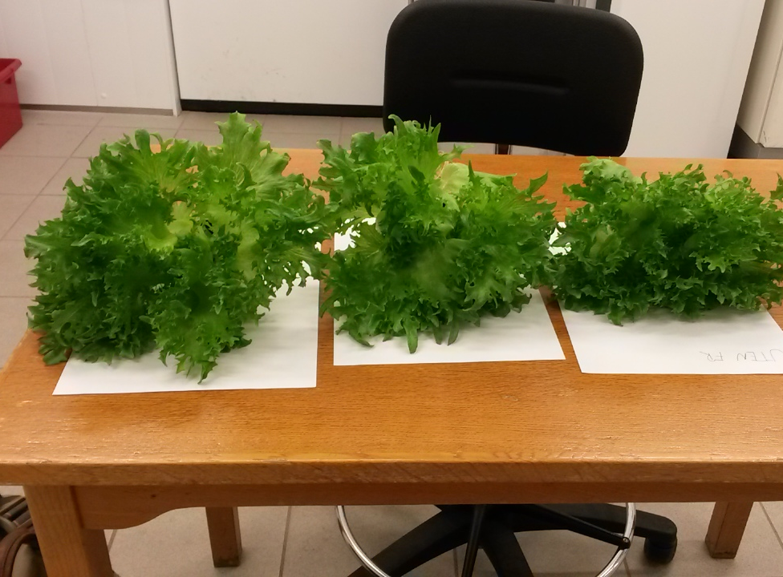
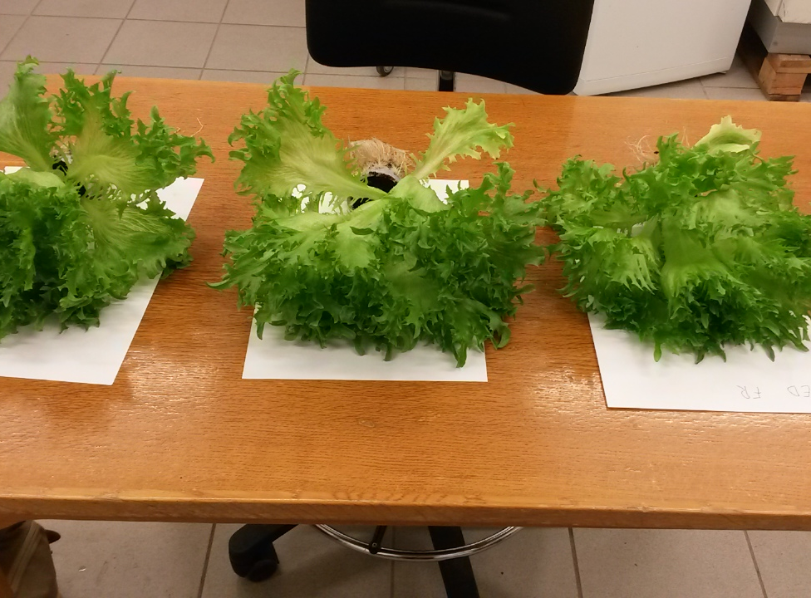
Appendix:
Figure 4 shows the lettuce with FR treatment for the upper picture and without for the bottom one.

